Prerequisites:
Program that does an HTTP API call

Program that does an HTTP API call

Program that does an HTTP API call

https://www.youtube.com/watch?v=W6NZfCO5SIk&t=0s
what is js?
Setting up development environment
js in browser
separation of concerns
js in nodes
variables
constants
Primitive/values types
- string
- number
- Boolean
- undefined
- null
Dynamic typing let name=”Faheem” it tendec to change to number but string name =”Faheem” Don’t
Objects
Arrays
Functions
- arguments :- pass into fxn which is being invoked/called.
- parameters:- are pass into fxn to read arguments value .
Types of function console.log()is also a function call.

Lect 1.1
https://slides.com/harkiratsingh-3/100xdevs-cohort
//
let array=[
{name:'Faheemuddin',
lastName:'Naseem',
age:23
},
{
name:'Gazzu',
lastName:'Bhajju',
age:24
}
]
for(let i=0;i<array.length;i++){
console.log(array[i].name +" "+array[i].lastName+' is ' +array[i].age+" old");
}
**---------------------------**------------------------------------------***
sum of all number between 2 number
function sum(firstIndex,secondIndex){
let Sum=0;
for(let i=firstIndex;i<=secondIndex;i++){
Sum+=i;
}
return Sum;
}
let result=sum(1,100);
console.log(result);

**------------------------------------------------------------------------------------------------**

// CallBack function
function sum(index1,index2){
return index1+index2;
}
function multiply(index1,index2){
return index1*index2;
}
function divide(index1,index2){
return index1/index2;
}
function doArithmetic(firstElement,secondElement,arithmeticfn){
return arithmeticfn(firstElement,secondElement);
}
let result=doArithmetic(4,2,multiply);
console.log(result);

**--------------------------------------------------------------------------------------**
// simple pattern problem
function createPattern(n){
for(let i=0;i<n;i++){
let stringtoprint="";
for(let j=0;j<=i;j++){
stringtoprint+='*';
}
console.log(abc);
}
}
createPattern(5);
output:-
*
**
***
****
*****
**-----------------------------------------------------------------------------------**
function createPattern(n){
for(let i=1;i<=n;i++){
let abc="";
for(let j=1;j<=n-i;j++){
abc+=' ';
}
for(let j=1;j<=(2*i-1);j++){
abc+='*';
}
console.log(abc);
}
}
createPattern(5);

output:-
*
***
*****
*******
*********
**-------------------------------------------------------------------------------------------**

// Here it become familiar for me to use function and callBack function

---> js is single threaded means it work on 1 cpu so no proper utilisation of resources

function sum(n){
let Sum=0;
for(let i=0;i<n;i++){
Sum+=i;
}
return Sum;
}
let startTime=new Date().getTime();
console.log(sum(100000));
let endTime=new Date().getTime();
console.log((endTime-startTime)/1000);
output:-
4999950000
0.014
if we take larger value then it takes much more time to calculate b/c js is single threaded.

-->If js has multiple work to do then it will complete first task then will jump to another task.
-->js work can’t be distributed to multiple core.

https://www.freecodecamp.org/news/synchronous-vs-asynchronous-in-javascript/

Synchronous JavaScript – How the Function Execution Stack Works
So what happens when you define a function and then invoke it? The JavaScript engine maintains a stack data structure called function execution stack. The purpose of the stack is to track the current function in execution. It does the following:
- When the JavaScript engine invokes a function, it adds it to the stack, and the execution starts.
- If the currently executed function calls another function, the engine adds the second function to the stack and starts executing it.
- Once it finishes executing the second function, the engine takes it out from the stack.
- The control goes back to resume the execution of the first function from the point it left it last time.
- Once the execution of the first function is over, the engine takes it out of the stack.
- Continue the same way until there is nothing to put into the stack.
The function execution stack is also known as the Call Stack.

Asynchronous JavaScript – How Browser APIs and Promises Work
The word asynchronous means not occurring at the same time.
Typically, executing things in sequence works well. But you may sometimes need to fetch data from the server or execute a function with a delay, something you do not anticipate occurring NOW. So, you want the code to execute asynchronously.
In these circumstances, you may not want the JavaScript engine to halt the execution of the other sequential code. So, the JavaScript engine needs to manage things a bit more efficiently in this case.
We can classify most asynchronous JavaScript operations with two primary triggers:
- Browser API/Web API events or functions. These include methods like setTimeout, or event handlers like click, mouse over, scroll, and many more.
- Promises. A unique JavaScript object that allows us to perform asynchronous operations.

How to Handle Browser APIs/Web APIs
function printMe() {
console.log('print me');
}

function test() {
console.log('test');
}

setTimeout(printMe, 2000); ///it will call printme fxn after 2 sec in that time
will call next line of code.
//That's where the asynchronous mechanism kicks in.
test();
output:-
test
printMe

How the JavaScript Callback Queue Works (aka Task Queue)
The engine creates a loop to look into the queue periodically to find what it needs to pull from there. It pulls a callback function from the queue to the call stack when the stack is empty. Now the callback function executes generally as any other function in the stack. The loop continues. This loop is famously known as the Event Loop.
So, the moral of the story is:
- When a Browser API occurs, park the callback functions in a queue.
- Keep executing code as usual in the stack.
- The event loop checks if there is a callback function in the queue.
- If so, pull the callback function from the queue to the stack and execute.
- Continue the loop.
Alright, let's see how it works with the code below:
function f1() {
console.log('f1');
}

function f2() {
console.log('f2');
}

function main() {
console.log('main');

setTimeout(f1, 0);

f2();
}

main();
}
Output:-
main
f2
f1
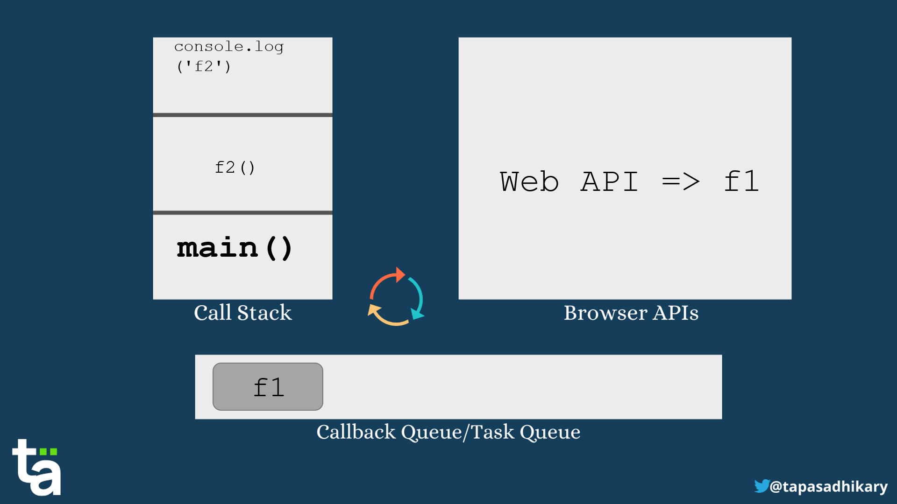
Here are steps written out:
- The main() function gets inside the call stack.
- It has a console log to print the word main. The console.log('main') executes and goes out of the stack.
- The setTimeout browser API takes place.
- The callback function puts it into the callback queue.
- In the stack, execution occurs as usual, so f2() gets into the stack. The console log of f2() executes. Both go out of the stack.
- The main() also pops out of the stack.
- The event loop recognizes that the call stack is empty, and there is a callback function in the queue.
- The callback function f1() then goes into the stack. Execution starts. The console log executes, and f1() also comes out of the stack.
- At this point, nothing else is in the stack and queue to execute further.
I hope it's now clear to you how the asynchronous part of JavaScript works internally

How the JavaScript Engine Handles Promises
In JavaScript, promises are special objects that help you perform asynchronous operations.
You can create a promise using the Promise constructor. You need to pass an executor function to it. In the executor function, you define what you want to do when a promise returns successfully or when it throws an error. You can do that by calling the resolve and reject methods, respectively.
Here is an example of a promise in JavaScript:
const promise = new Promise((resolve, reject) =>
resolve('I am a resolved promise');
);
After the promise is executed, we can handle the result using the .then() method and any errors with the .catch() method.
promise.then(result => console.log(result))
imp-->You use promises every time you use the fetch() method to get some data from a store.
The point here is that JavaScript engine doesn't use the same callback queue we have seen earlier for browser APIs. It uses another special queue called the Job Queue.

What is the Job Queue in JavaScript?
Every time a promise occurs in the code, the executor function gets into the job queue. The event loop works, as usual, to look into the queues but gives priority to the job queue items over the callback queue items when the stack is free.
The item in the callback queue is called a macro task, whereas the item in the job queue is called a micro task.
So the entire flow goes like this:
- For each loop of the event loop, one task is completed out of the callback queue.
- Once that task is complete, the event loop visits the job queue. It completes all the micro tasks in the job queue before it looks into the next thing.
- If both the queues got entries at the same point in time, the job queue gets preference over the callback queue.
Now, let's look at an example to understand this sequence better:
function f1() {
console.log('f1');
}

function f2() {
console.log('f2');
}

function main() {
console.log('main');

setTimeout(f1, 0);

new Promise((resolve, reject) =>
resolve('I am a promise')
).then(resolve => console.log(resolve))

f2();
}

main();
output:-
main
f2
I am a promise
f1
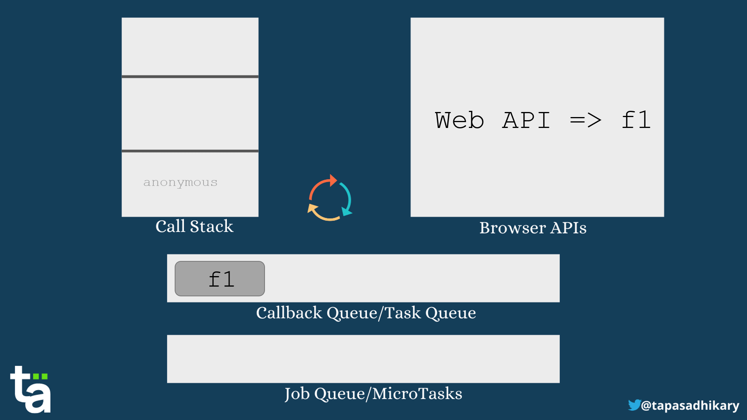
Here is a Quiz for You!
function f1() {
console.log('f1');
}

function f2() {
console.log('f2');
}

function f3() {
console.log('f3');
}

function main() {
console.log('main');

setTimeout(f1, 50);
setTimeout(f3, 30);

new Promise((resolve, reject) =>
resolve('I am a Promise, right after f1 and f3! Really?')
).then(resolve => console.log(resolve));

new Promise((resolve, reject) =>
resolve('I am a Promise after Promise!')
).then(resolve => console.log(resolve));

f2();
}

main();
Here is the expected output:
main
f2
I am a Promise, right after f1 and f3! Really?
I am a Promise after Promise!
F3
f1
In Summary
- The JavaScript engine uses the stack data structure to keep track of currently executed functions. The stack is called the function execution stack.
- The function execution stack (aka call stack) executes the functions sequentially, line-by-line, one-by-one.
- The browser/web APIs use callback functions to complete the tasks when an asynchronous operation/delay is done. The callback function is placed in the callback queue.
- The promise executor functions are placed in the job queue.
- For each loop of the event loop, one macro task is completed out of the callback queue.
- Once that task is complete, the event loop visits the job queue. It completes all the micro-tasks in the job queue before it looks for the next thing.
- If both the queues get entries at the same point in time, the job queue gets preference over the callback queue.

Programs to write to a file
Programs that does an HTTP API call
let fs=require('fs');
let data='data is being written';
fs.writeFile('file.txt',data,(err)=>{
if(err)throw err;
})

Program to read from a file
let fs=require('fs');
fs.readFile('file.txt',(err,data)=>{
if(err)throw err;
console.log("File content: "+data);
})

//same code for sum
let fs=require('fs');
function sum(n){
let Sum=0;
for(let i=1;i<=n;i++){
Sum+=i;
}
console.log(Sum);
}
function fileisRead(fileContent){
sum(fileContent);
}
fs.readFile('file.txt',(err,data)=>{
if(err)throw err;
fileisRead(data);
})

--> js is loosly typed while c++ is tightly typed
b/c when we take parameters in function we don’t need to specifiy its typeof it can string ,int,char,bool
|for Ex;- see above example
-->js is interpreted langugae :- as it goes line by line to execute
while c++ is compiled langage it shows error if somewhere i wrote int in place of string.here nothing will print .
-->native js? Var x=2; for loops , Date()
API
- exposed by run time environment
- fetch
- setTimeout
  - setInterval

